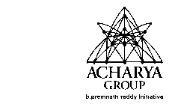
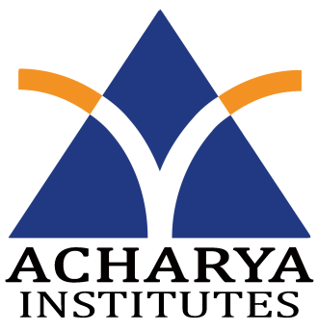
Department of Information Science and Engineering
Acharya Institute of Technology
Acharya Dr. Sarvepalli Radhakrishnan Road,
Soldevanahalli, Bangalore-560107

Date: 21/3/2016
Weekly Project Progress Report

Title of the Project: Android Based Course Delivery and Evaluation System.
Conducted at: Acharya Institute of Technology
Name and USN of the students
1. Bidish Basu, 1AY12IS021
2. Nandan A, 1AY12IS051
3. Vignesh N K, 1AY12IS096
4. Y G Sriram, 1AY12IS100
Name of the Guide: Prof. C K Marigowda
First Week Project Progress report, Dated from 15/2/2016 to 21/2/2016

In the First week we,
- Surveyed about the project.
- Started learning about the basics of android programming.

Guide signature with Date HOD (ISE Dept.)

Department of Information Science and Engineering
Acharya Institute of Technology
Acharya Dr. Sarvepalli Radhakrishnan Road,
Soldevanahalli, Bangalore-560107

Date: 21/3/2016
Weekly Project Progress Report

Title of the Project: Android Based Course Delivery and Evaluation System.
Conducted at: Acharya Institute of Technology
Name and USN of the students
1. Bidish Basu, 1AY12IS021
2. Nandan A, 1AY12IS051
3. Vignesh N K, 1AY12IS096
4. Y G Sriram, 1AY12IS100
Name of the Guide: Prof. C K Marigowda
Second Week Project Progress report, Dated from 22/2/2016 to 28/2/2016

In the Second week we,
- Started working on the backend.
- Learnt about the xampp, wampp and lampp softwares.

Guide signature with Date HOD (ISE Dept.)

Department of Information Science and Engineering
Acharya Institute of Technology
Acharya Dr. Sarvepalli Radhakrishnan Road,
Soldevanahalli, Bangalore-560107

Date: 21/3/2016
Weekly Project Progress Report

Title of the Project: Android Based Course Delivery and Evaluation System.
Conducted at: Acharya Institute of Technology
Name and USN of the students
1. Bidish Basu, 1AY12IS021
2. Nandan A, 1AY12IS051
3. Vignesh N K, 1AY12IS096
4. Y G Sriram, 1AY12IS100
Name of the Guide: Prof. C K Marigowda
Third Week Project Progress report, Dated from 29/2/2016 to 6/3/2016

In the Third week we,
- Learnt about MySql and created the backend tables.
- Made connections between the frontend and the backend.

Guide signature with Date HOD (ISE Dept.)

Department of Information Science and Engineering
Acharya Institute of Technology
Acharya Dr. Sarvepalli Radhakrishnan Road,
Soldevanahalli, Bangalore-560107

Date: 21/3/2016
Weekly Project Progress Report

Title of the Project: Android Based Course Delivery and Evaluation System.
Conducted at: Acharya Institute of Technology
Name and USN of the students
1. Bidish Basu, 1AY12IS021
2. Nandan A, 1AY12IS051
3. Vignesh N K, 1AY12IS096
4. Y G Sriram, 1AY12IS100
Name of the Guide: Prof. C K Marigowda
Fourth Week Project Progress report, Dated from 7/3/2016 to 13/3/2016

In the Fourth week we,
- Created the admin web page to enter the details in the database.
- Learnt about the Json parser to connect PHP pages to android application.

Guide signature with Date HOD (ISE Dept.)

Department of Information Science and Engineering
Acharya Institute of Technology
Acharya Dr. Sarvepalli Radhakrishnan Road,
Soldevanahalli, Bangalore-560107

Date: 21/3/2016
Weekly Project Progress Report

Title of the Project: Android Based Course Delivery and Evaluation System.
Conducted at: Acharya Institute of Technology
Name and USN of the students
1. Bidish Basu, 1AY12IS021
2. Nandan A, 1AY12IS051
3. Vignesh N K, 1AY12IS096
4. Y G Sriram, 1AY12IS100
Name of the Guide: Prof. C K Marigowda
Fifth Week Project Progress report, Dated from 14/3/2016 to 20/3/2016

In the Fifth week we,
- Created the login page for students’ in the application.
- Created the FTP verification for the login.

Guide signature with Date HOD (ISE Dept.)

